**What is a framework ?**

* **A framework is a set of classes and interfaces which provide a readymade architecture .**
* **An optimal object-oriented design always includes a framework with a collection of classes such that all the classes perform the same kind of task .**

**Collections in java**

* The java collections framework provides a set of interface and classes to implement various data structures and algorithms .
* Java collections can achieve all the operations that you perform on a data such as searching , sorting , insertion , manipulation , and deletion .
* Java collection means a single unit of objects .(i.e. a group)
* Java collection provides many interfaces .(Set , list , queue , deque) and classes(ArrayList , Vector , LinkedList , PriorityQueue , Hashset , LinkedHashSet , TreeSet) .

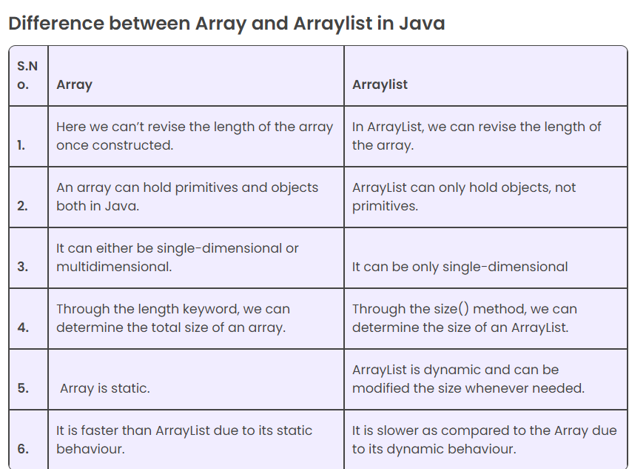

The java Collections framework is a api which is combination of class and interface .

Collection is a interface which inherite iterable class .

Difference between array list and array ?

Array – homogeneous , primitive and non primitive ,

array list – store an object form type data in array , fixed runtime .

**Hierarchy of collection framework**

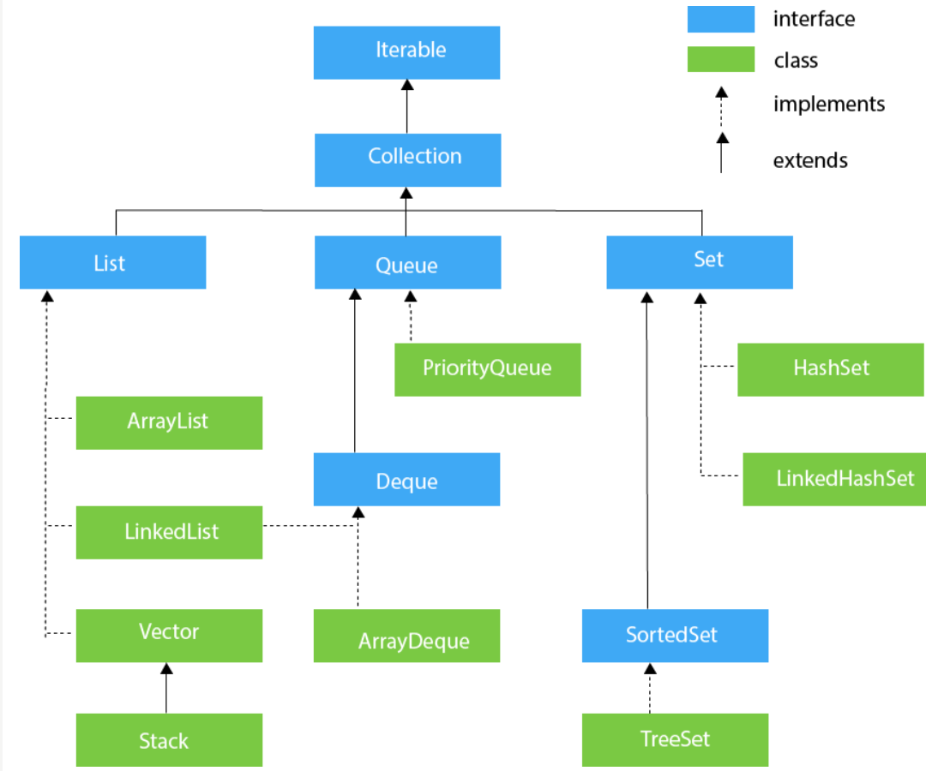

**Methods of collection interface**

|  |  |  |
| --- | --- | --- |
| **No** | **Method** | **Description** |
| **1.** | public boolean add(E e) | |  | | --- | | It is used to insert an element in this collection | |
| **2.** | public Boolean addAll(Collection<? extends E> c) | It is used to insert the specified collection elements in the invoking collection. |
| **3.** | public boolean remove(Object element) | It is used to delete an element from the collection. |
| **4.** | public boolean removeAll(Collection<?> c) | It is used to delete all the elements of the specified collection from the invoking collection. |
| **5.** | default boolean removeIf(Predicate<? super E> filter) | It is used to delete all the elements of the collection that satisfy the specified predicate. |
| **6.** | It is used to delete all the elements of the collection that satisfy the specified predicate. | It is used to delete all the elements of invoking collection except the specified collection. |
| **7.** | public int size() | It returns the total number of elements in the collection |
| **8.** | public void clear() | It removes the total number of elements from the collection. |
| **9.** | public boolean contains(Object element) | It is used to search an element. |
| **10.** | public boolean containsAll(Collection<?> c) | It is used to search the specified collection in the collection. |
| **11.** | public Iterator iterator() | It returns an iterator. |
| **12.** | public Object[] toArray() | It converts collection into array. |
| **13.** | public <T> T[] toArray(T[] a) | It converts collection into array. Here, the runtime type of the returned array is that of the specified array. |
| **14.** | public boolean isEmpty() | It checks if collection is empty. |
| **15** | default Stream<E> parallelStream() | It returns a possibly parallel Stream with the collection as its source. |
| **16** | default Stream<E> stream() | It returns a sequential Stream with the collection as its source. |
| **17** | default Spliterator<E> spliterator() | It generates a Spliterator over the specified elements in the collection. |
| **18** | public boolean equals(Object element) | It matches two collections. |
| **19** | public int hashCode() | It returns the hash code number of the collection. |